**FS101055: *E. coli* O157 super-shedding in cattle and mitigation of human risk Project report 13/04/16**

**Objective 1:** To determine the excretion dynamics and transmission frequencies of wild type *E. coli* O157 strains under controlled experimental conditions

**Progress relating to Deliverables:**

Deliverables completed since the last reporting date (30/09/15) are detailed in Table 1. All deliverables within this objective have been completed with the exception of 1.3.3 for which the statistical analysis is not yet completed.

Table 1: Deliverables completed since 30/09/15

|  |  |  |  |  |
| --- | --- | --- | --- | --- |
| **DELIVERABLE NUMBER** | **TARGET**  **DATE** | **DELIVERABLE DETAILS** | **PROGRESS** | **PROGRESS** |
| **1.1.6** | **MRI, BIOSS, UOE** | **01/09/2015** | Statistical analyses of excretion data from PT21/28 and PT32 strains | Completed |
| **1.3.1** | **MRI, UOE** | **01/12/2015** | Excretion and transmission data for a PT21/28 (super-shedding Lineage III) *E. coli* O157 strain no longer containing the Stx2 prophage. | Completed |
| **1.3.2** | **MRI, UOE** | **01/02/2016** | Measurement of innate and adaptive responses in animals colonised with the Stx2 prophage-excised strain and comparison of these with responses to the Stx2+ parental strain. | Completed |
| **1.3.3** | **MRI, UOE** | **01/05/2016** | Definition of the role of a Stx2 prophage on the excretion dynamics and transmission frequencies of a PT21/28 (super-shedding lineage III) strain | Ongoing |

**Progress in relation to Sub-tasks:**

***01/01/05*** *Statistical analyses of shedding and environmental data for the PT21/28 vs. PT32 E. coli O157 strains* (**COMPLETED)**

***01/03/01*** *Excretion and transmission data for a PT21/28 (super-shedding Lineage III) E. coli O157 strain no longer containing the Stx2 prophage* **(COMPLETED)**

***01/03/02*** *Measures of innate and adaptive immune responses of animals in response to colonisation with the Stx2 excised PT21/28 strain* **(COMPLETED)**

***01/03/03*** *Statistical analysis of excretion and transmission data obtained in 1.3.1 with data obtained from the wild-type Stx2 positive strain obtained in 01/01 and 01/02* **(ONGOING)**

**Scientific progress**

Deliverable 1.1.6

Data analysis has now been completed by BioSS for excretion data for the wild-type PT21/27 and PT32 strains (Trials 1&2). In the previous report transmission was significantly higher for the wild-type PT21/28 strain compared to the PT32 strain, with the challenge strain detectable in 10/10 sentinel calves for the PT21/28 strain compared to 0/10 for the PT32 strain (*P* < 0.0001). With the PT21/27 strain, only one of the naïve sentinels shed the challenge strain at super-shedding levels (i.e. >103 CFU/g faeces). Excretion data for the two strains has now been analysed using a Poisson generalised mixed model with logarithm link function fitted by maximum likelihood (Laplace approximation). A statistically significant effect of strain was observed (p = 0:0019), with the PT32 strain producing significantly lower mean CFU/g counts than the PT21/28 strain. Evidence of a significant interaction effect between strain and time as also obtained (p = 0:0071) (Fig 1).

M:\FSA EHEC GRANT\BioSS analysis\SS_report_Page_06.tif

**Figure 1.** Mean daily bacterial shedding following oral challenge of calves (n=6) with the PT21/28 strain vs. the PT32 strain. The graphs shows the model predicted means (in logarithm of CFU/g scale) for each strain at each day post-challenge and corresponding 95% confidence bands.

Deliverable 1.3.1

In our previous report we presented data on bacterial excretion from calves challenged with the wild-type PT21/28 strain with isogenic strains with either the Stx2a-encoding prophage removed, or where the ISEc8 insertion sequence within the *stx2a* A subunit gene was removed, allowing production of Stx2a A subunit (Trial 3). Analysis of this excretion data has now been completed and shows no significant difference between any of the strains (P = 0:9475, Fig 2).

M:\FSA EHEC GRANT\BioSS analysis\SS_report_Page_11.tif

**Figure 2.** Mean daily bacterial shedding following oral challenge of calves (n=6) with wild type PT21/28 strain (A), isogenic Stx2a-ISEc8 repaired strain (B) or isogenic Stx2a-prophage mutant strain (C). The graphs shows the model predicted means (in logarithm of CFU/g scale) for each strain at each day post-challenge and corresponding 95% confidence bands.

Deliverable 1.3.2

Immune response measurements have been completed in calves from the experimental challenge study described in Deliverable 1.3.1. As in previous studies, cellular immune responses to *E. coli* O157 secreted protein preparations were undetectable following challenge with all three strains, probably as a result of Stx mediated immune suppression. In contrast, *E. coli* O157-specific antibody responses were induced following challenge but were no different between the three strains (wild-type, Stx2a-prophage mutant or Stx2a-ISEc8 repaired strains).

Deliverable 1.3.3

Further analysis of the Stx2a-ISEc8 repaired strain used in cattle Trial 3 indicated that while levels of Stx2a protein were increased following removal of ISEc8, verocytotoxicity levels were not increased, suggesting that the Stx2a produced by this strain was not functionally active. Sequencing of the Stx2a A and B subunits identified a single base change within the B subunit in an area which was likely to be involved in binding of the Stx2a to the Gb3 receptor. Therefore, a further strain was generated (Stx2a-ISEc8 repaired strain 2.0) in which the base change in the B subunit was reverted back to the original base. This now resulted in a PT21/28 strain which produced functional Stx2a (Fig 3).

M:\E5915 FSA TRIAL 4\Repaired 9000 St2 expression and toxicity.tif

**Figure 3.** Stx2 protein expression (A) and verotoxicity (B) of the wild-type PT21/28 strain (WT 9000) and the Stx2a-ISEc8 repaired strain 2.0 (9000 Stx2a Repaired) indicating increased Stx2 expression and verotoxicity of the repaired strain.

**B**

**A**

This Stx2a-ISEc8 repaired strain 2.0 was subsequently used to perform a transmission study (Trial 4) in which 17 Holstein-Friesian calves, screened as negative for *E. coli* O157 by IMS and qPCR, were assigned to three separate rooms (C1-3) within the Moredun High Security Unit (C1 n=7, C2 n=5, C3 n=5). An additional five *E. coli* O157 negative calves acted as unchallenged controls for immunological studies. Calves in C1 were orally challenged with 109 CFU Stx2a-ISEc8 repaired strain 2.0. At day 5 post-challenge one colonized calf each from C1 was moved into pens C2 and C3 to act as a source of infection for the naïve in-contact sentinel calves and levels of *E. coli* O157 challenge strain within the faeces and the environment were monitored on a daily basis over a 25 day period. The transmission results are shown in Fig 4. 10/10 of the naïve sentinels became colonized with the challenge strain and 9/10 of these calves shed the challenge strain at super-shedding levels (>103 CFU/g). Interestingly, the mean daily shedding of the Stx2a-ISEc8 repaired strain 2.0 was similar to the wild-type strain (Fig. 5).

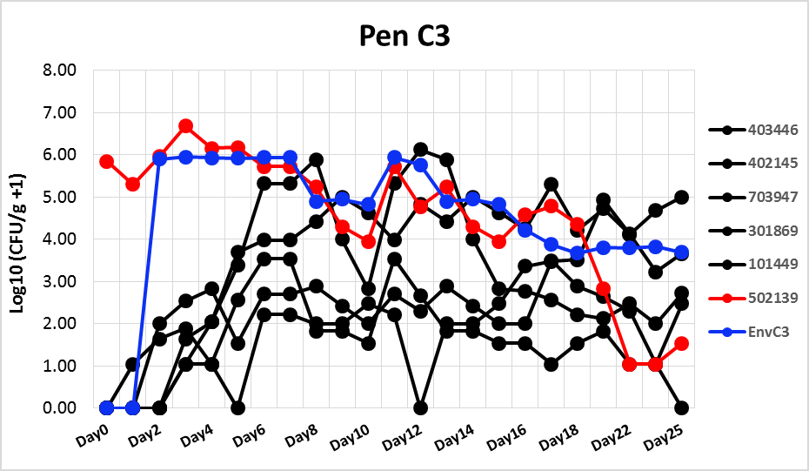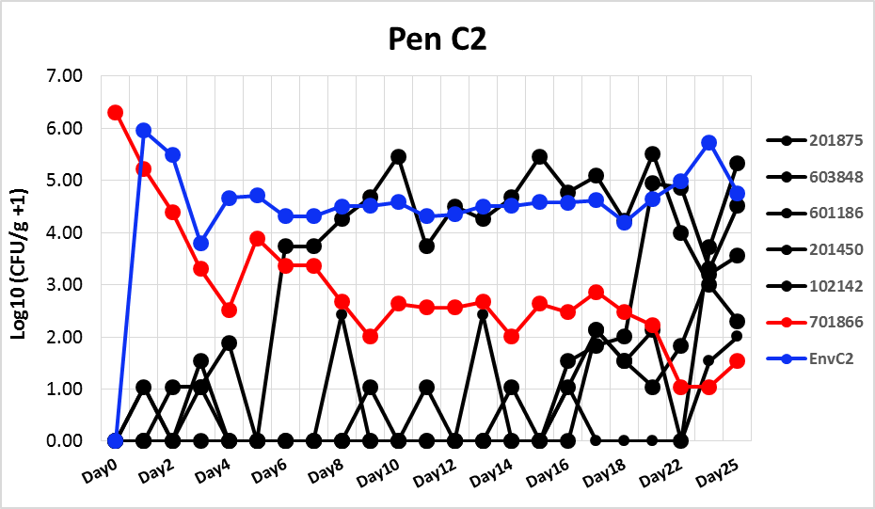

**Figure 4.** Transmission of Stx2a-ISEc8 repaired strain 2.0 to naïve in-contact sentinels. One calf each previously orally challenged with Stx2a-ISEc8 repaired strain 2.0 and shedding the bacteria at ~106 CFU/g faeces was moved into two rooms of 5 *E. coli* O157 naïve sentinel calves and levels of bacteria within the faeces and the environment were monitored over a 25 day period. Red dots/lines indicate shedding from the orally challenged calves; blue dots/lines indicate levels of challenge strain within the environment; black dots/lines indicate bacterial levels within the naïve in-contact sentinels.

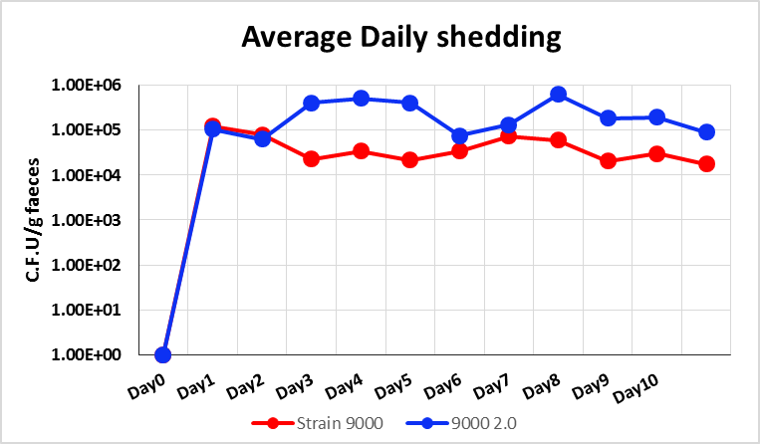

**Figure 5.** Mean bacterial shedding from calves challenged with wild-type PT21/28 strain (Strain 9000, red) or an isogenic Stx2a-ISEc8 repaired strain 2.0 (9000 2.0) following oral challenge with ~109 CFU of each strain.

These results suggest that a functional Stx2a gene is associated with higher transmission rates, and importantly the generation of new super-shedding calves. These results is highly consistent with previous epidemiological evidence, and as super-shedding cattle are responsible for most cattle-to-cattle transmissions (ref), **suggest that Stx2a carriage plays an important role in persistence of *E. coli* O157 in cattle populations**. The data is currently being compiled for statistical analysis by BioSS and for use in parameterising mathematical models of *E. coli* transmission in cattle under Deliverable 3.2.

**PhD studentship 1**

Following on from the previous report, this studentship has demonstrated that the immune-stimulatory effects of colonization with wild-type PT21/28 strain 9000 on local (pre-scapular) lymph node responses following s.c. immunization are lost when either (i) the Stx2a B subunit is mutated such that the Stx no longer has verotoxicity activity; (ii) the Stx2a encoding prophage is removed; (iii) functional Stx2a A subunit is restored by removal of the ISEc8 element from the wild-type strain. As Stx B subunit has been shown to posess adjuvant activities (ref), these results suggest that production of Stx2a B subunit without the toxic Stx2a A subunit, may partly explain the observed immunostimulatory effects of the wild-type PT21/28 strain.

In a separate study in collaboration with the FLI Jena, Germany, the student has shown that vaccination of calves with a Stx toxoid leads to enhanced anti-*E.coli* O157 antibody levels in response to field challenge with the bacteria. This result is consistent with an immunomodulatory effect of Stx which is neutralised by vaccination with Stx toxoid, and suggests that Stx-mediated immune suppression can be overcome by vaccination.